Multi-Media Pallet

A multi-media pallet provides rules on the use of colours, fonts, icons and geometry in the website design. We need established and cohesive design choices - it helps us in ensuring we produce a professional result.

Ensure these choices are in-line with client requirements for "Accessible" and "Concise".

Document should include a few alternative pallets - coming to a conclusion for one pallet in a design review, and then formalising.

Only fonts to be used are: Tahoma, Calibri, Helvetica, Arial, Verdana, and Times New Roman. Do not use different fonts when talking about the same topic.

Minimum font size: 14

If text is going over an image make sure there is a grey background with an opacity of at least 50%

Logo needs to be present on each page in the upper left corner.

Navigation bar that follows you as you scroll down the page.

No custom shaped

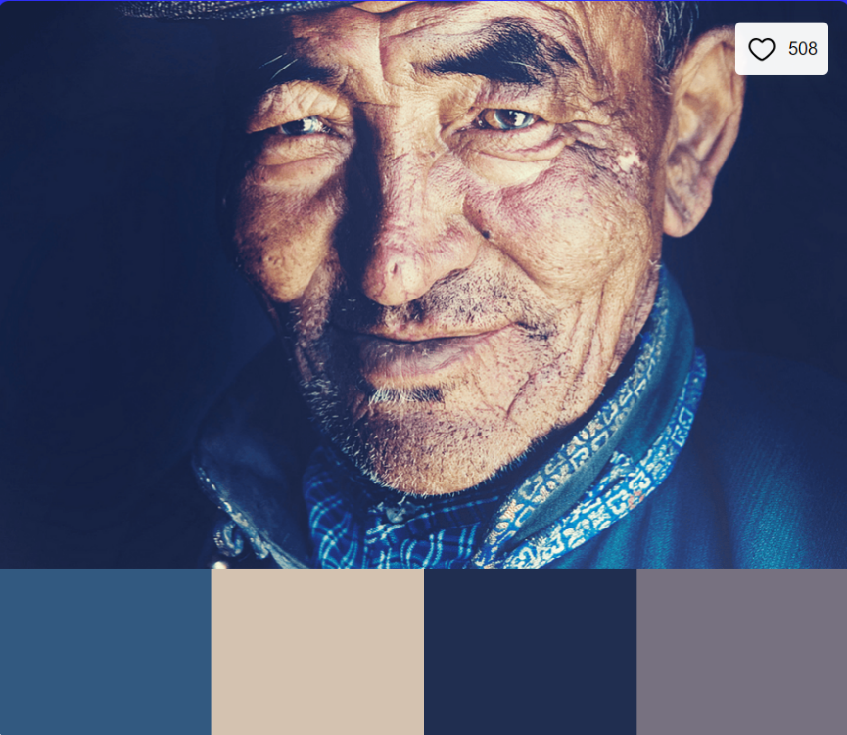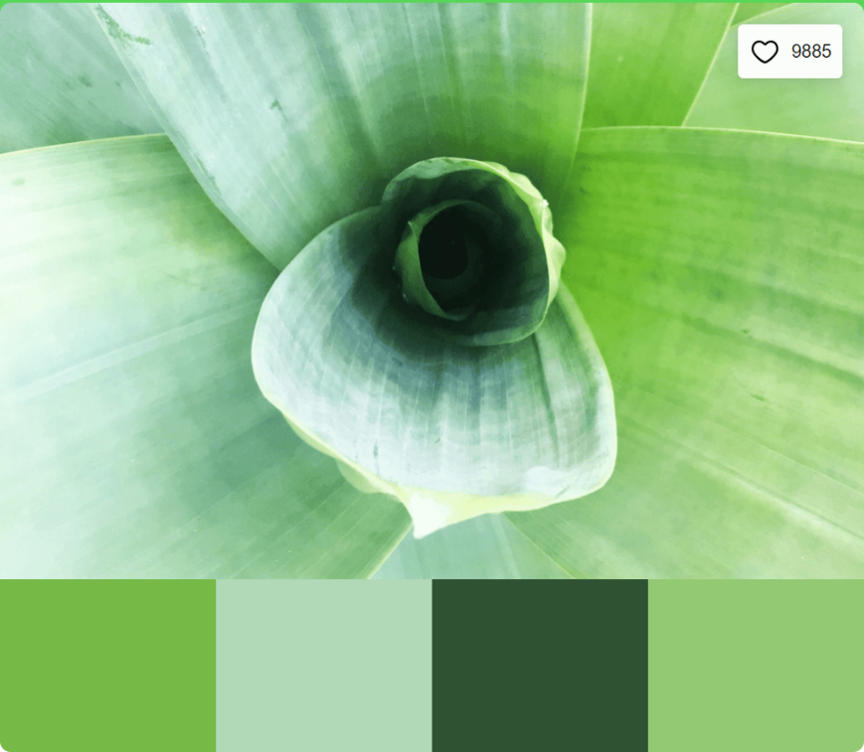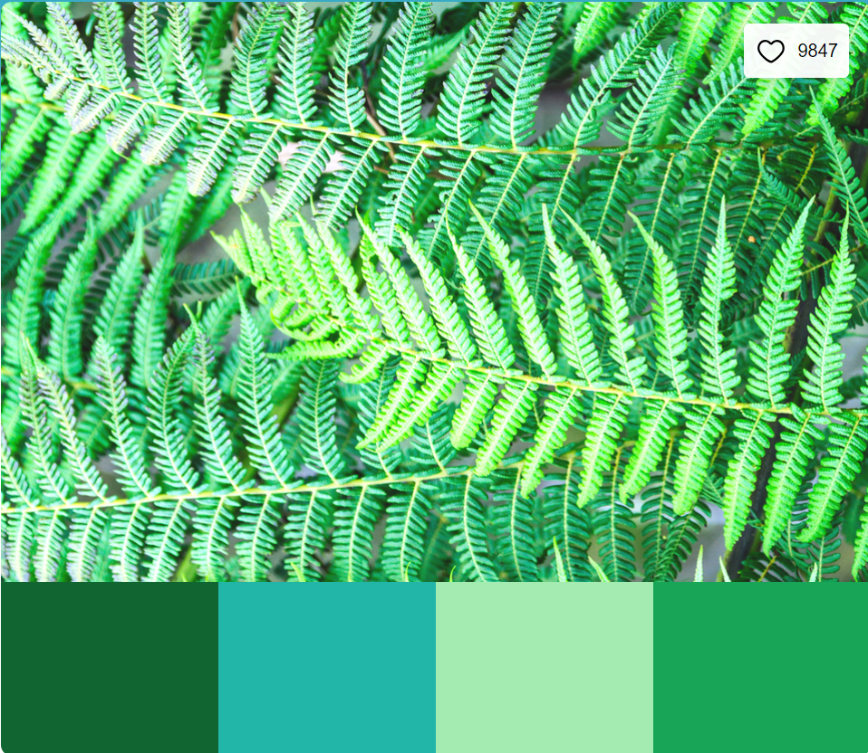

Colour Palette: Green Blaze

Colours: Lime Green(76B947), Kelly Green(B1D8B7), Seafoam Green(2F5233), Spearmint(94C973).

This scheme is similar to the top one however, it is all green related allowing for a variety of designs which flow well into each other.

Colour Palette: Classic Gentleman

Colours: Blue(325980), Ivory(D4C2B0), Navy Blue(202E50), Purple Haze(777180).

This colour palette is calming without any unneeded bursts of colour. It is also colouring that older people enjoy as these were main colours they would have seen around the place.

Colour Palette: Under The Ferns

Colours: Green(116530), Blue Green(21B6A8), Neon Green(A3EBB1), Kelly Green(18A558).

The scheme of colours here are related to nature which fits well to our mission statement. They aren’t ‘in your face’ colours however they do catch your attention and are subtle on your eyes.



I have chosen to use this colour palette as it flows well into each other while still fitting the theme of the website. I have taken the 4 colours in this palette and created an additional 5 which can be used for background and other items. This allows for a greater variety and in turn makes each page more unique. The hex code has been added for each colour allowing for ease of use when using them.



|  |  |  |  |  |  |  |  |  |
| --- | --- | --- | --- | --- | --- | --- | --- | --- |
| 2F5233 | 63A051 | 97ED6E | 94C973 | A7DFA6 | B0EABF | B9F5D8 | B5E7C8 | B1D8B7 |